Figure List
PartⅠ

Chapter4 Ground Improvement with Admixture or Inclusion (Figs)’19.2.10

Fig.4.1 Adding amount and unconfined compression strength by soil type
Fig.4.2 Lime-group materials and unconfined compression strength of mixed mass
Fig.4.3 Determination of adding amount (Japan Lime Association, 2016)
Fig.4.4 Relationship between adding amount of quicklime and water content
Fig.4.5 Adding amount of quick lime and Plasticity index
Fig.4.6 Procedures of surface compaction with admixtures
Fig.4.7 Example of sand compaction pile method on loose sandy ground
(Takahashi, 2008)
Fig.4.8 Example of sand compaction pile method on soft clayey ground
(Takahashi, 2008)
Fig.4.9 Principle of SCP (Fudo Construction, 1971)
Fig.4.10 Plane arrangement of SCP (Fudo Construction, 1971)
Fig.4.11 Procedure of sand compaction pile
(Yasuda et al. 1996, Modified by authors).
Fig.4.12 Designing chart of SCP method for sandy ground
(Fudo Construction, 1971)
Fig.4.13 Principle of densification by SCP (Suematu, 1991)
Fig.4.14 Mechanism of bearing capacity on composite ground
(Suematu, 1991)
Fig.4.15 Shear strength of composite ground (Suematu, 1991)
Fig.4.16 Case history of SCP (Provision by JAFEC, 2016)
Fig.4.17 Effect of stone column for settlement (Som & Das, 2004)
Fig.4.18 Procedure of Stone Column Method (Civil Digital, 2017)
Fig.4.19 Wet-top Feed System (Zetas)
Fig.4.20 Dry-bottom Feed System (Zetas)
Fig.4.21 Failure of Stone Column (Barksdale and Bachus,1983)
Fig.4.22 Settlement reduction with stone columns (Greenwood and Thomson, 1984)
Fig.4.23 Results of ground improvement by SPT N Values (Basarkar et. al, 2009)

Symbol | Soil | w_{n} (%) | ρ_{t} (g/cm³)
◆ | SM | 32.8 | 1.776
■ | MH | 68.5 | 1.663
▲ | CH | 89.2 | 1.611
● | VH2 | 94.7 | 1.487
□ | OH | 230.7 | 1.194

Note

Fig.4.1 Adding amount and unconfined compression strength by soil type (Japan Cement Association, 2012) (Curing time: 28days)

Fig.4.2 Lime-group materials and unconfined compression strength of mixed mass (Japan Lime Association, 2016)

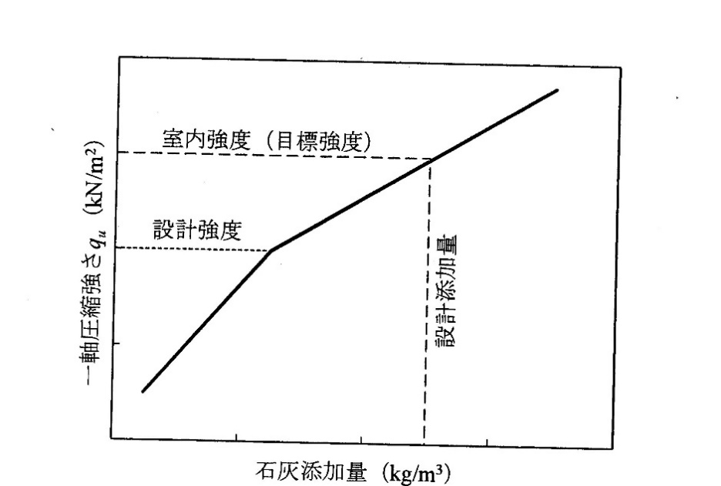
Target strength

Design strength
Design adding amount
Unconfined compression strength (kN/m²)
Amount of Solidifying material (kg/m³)
Fig.4.3 Determination of adding amount (Japan Lime Association, 2016)

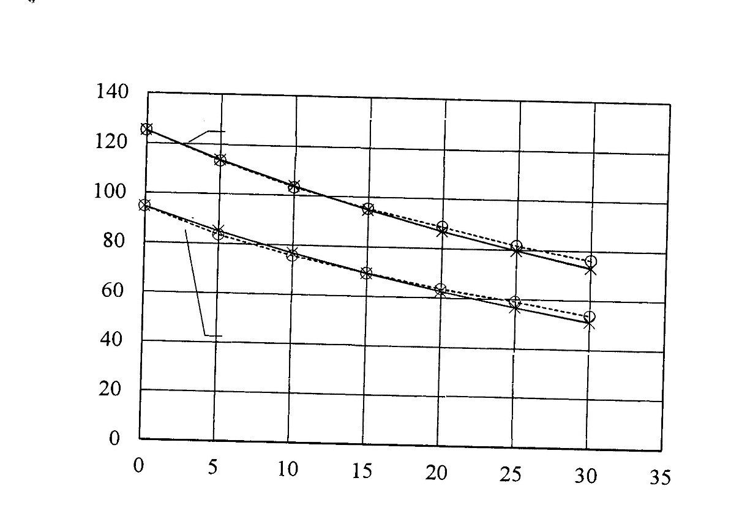
Adding amount of quick lime (%)
Water content w_{n} =125.2%
Water content
w_{n} =94.6 (％)
Water content (%)
Tested soil:
Volcanic cohesive soil
Fig.4.4 Relationship between adding amount of quicklime and water content (Japan Lime Association, 2016)
(中澤先生からOriginalを送って貰う)
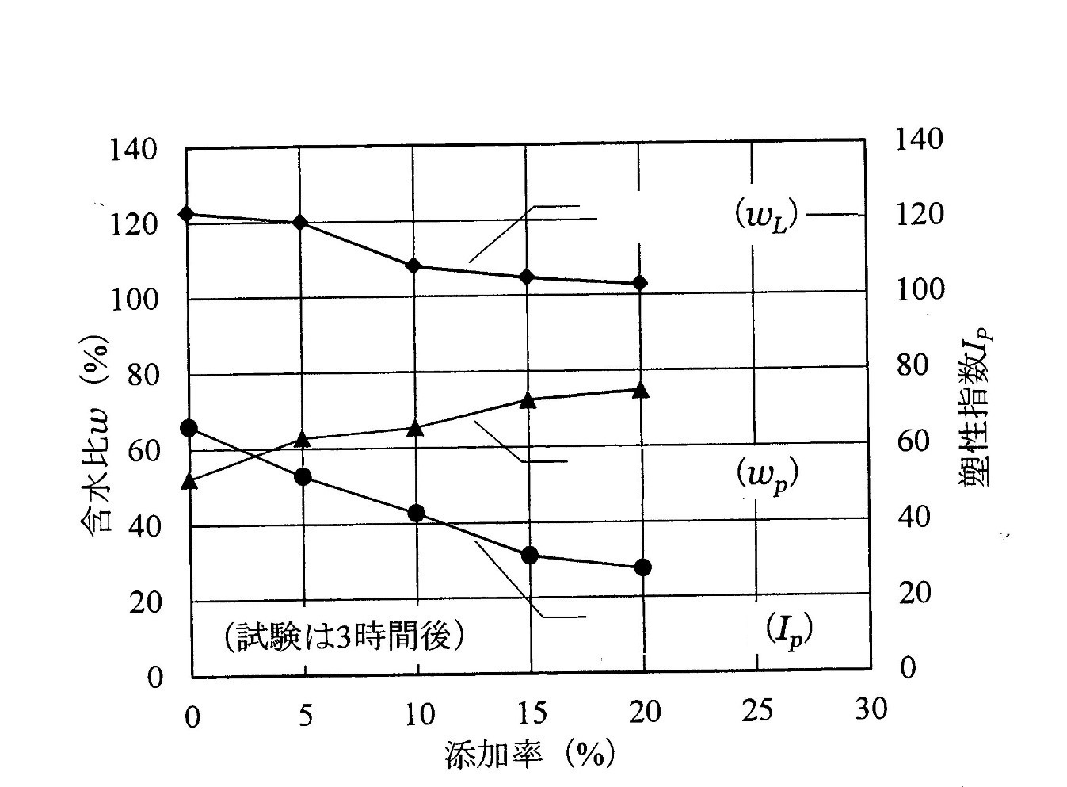
Plasticity index I_{p}
Water content w (%)
Adding amount (%)
3 hours after mixing
Liquid limit
Plastic limit
Plasticity index
Fig.4.5 Adding amount of quick lime and Plasticity index (Japan Lime Association, 2016
(中澤先生からOriginalを送って貰う)

Compacting
Grading
Mixing of soils and materials
Spreading of adding materials
Excavating and pulverizing of
soil layer

(a) On site mixing system
Preparing of adding materials
Compacting
Spreading and grading hem
Carrying of mixed materials
Mixing of soil and adding materials by mixing plant
Carrying soils from pits

(b) Plant mixing system

Loading and transporting
Compacting
Remixing
Spreading and grading
Excavating soil with adding materials
Spreading of adding materials at borrow pit

(c) Borrow pit mixing system
Fig.4.6 Procedures of surface compaction with admixtures

Quay wall
Sand compaction pile
Loose sandy
ground
Rubble mound

Fig.4.7 Example of sand compaction pile method on loose sandy ground
(Takahashi, 2008)

Soft clayey ground
Sand compaction piles
Road Embankment
Fig.4.8 Example of sand compaction pile method on soft clayey ground
(Takahashi, 2008)

a) Original ground
b) After improvement
$$e_{1}$$
Soil particles
Pore
Sand pile
$$e_{0}$$
Fig.4.9 Principle of SCP Ground Improvement in Sandy Ground
(Fudo Construction Co., Ltd. 1971)
（学生に書き直し）

X₂
X₁
x
x
x
x

c) Parallelogram (rectangular) pattern
- Equilateral triangular pattern
- Square pattern

Fig.4.10 Plane arrangement of SCP (Fudo Construction Co., Ltd. 1971)

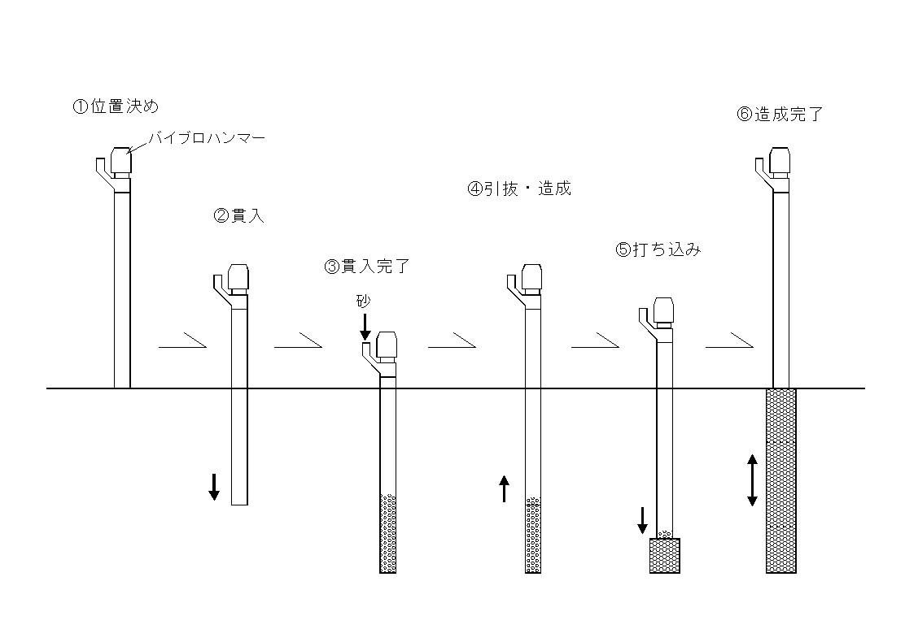
Step 3
Sand pile
Sand
Step 6
Step 5
Step 4
Step 2
Hopper
Casing
Vibrating hammer
Step 1
Step 1. Set the casing at the specified location.
Step 2. Actuate the vibrator for the casing to penetrate below the ground surface.
Step 3. Penetrate to the specified depth, then placed sand into casing through a hopper.
Step 4. Withdraw the casing top the specified level; the sand in the casing is discharged into the bored hole with compressed air.
Step 5. Insert the casing into the hole; the sand is compacted by vibration. Supply sand into casing.
Step 6. By repeating this procedure, the sand compaction pile is completed up to the ground surface.

Fig4.11 Procedure of SCP method (Modified from Yasuda et al. 1996).

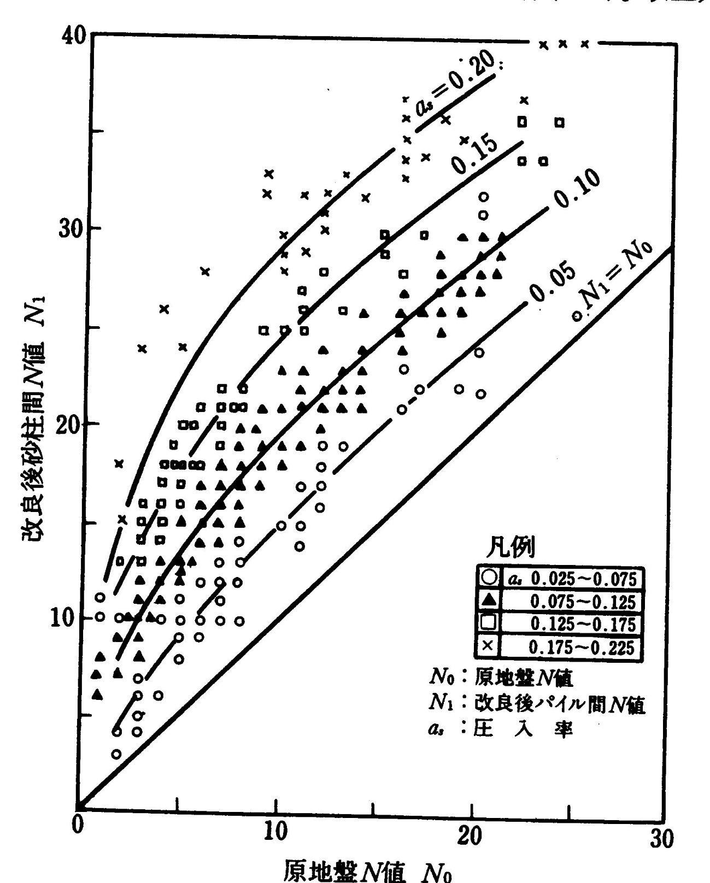
N-value after construction (N₁)
N-value of original ground (N₀ )
$N_{1}$=$N_{0}$
$a_{s}$=0.05
$a_{s}$=0.1
$a_{s}$=0.15
$a_{s}$=0.2
a_{s}: replacement rate
Fig.4.12 Designing chart of SCP method for Sandy Ground
(Modified from Fudo Construction Co., Ltd., 1971)
（Originalについては、原田さんにお尋ね）

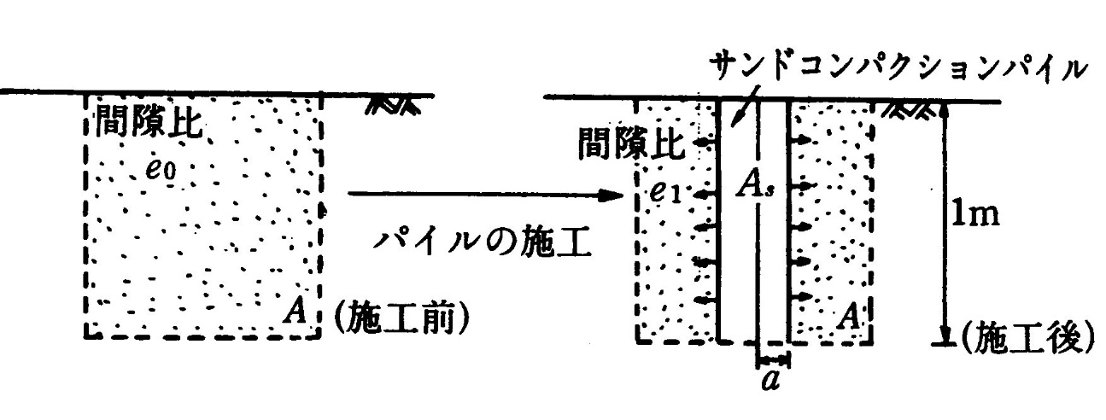
$$a$$
$$A_{s}$$
$$e_{1}$$
$$A$$
$$e_{0}$$
Sand compaction pile

Void ratio
A
$$1m$$
$$A$$
$$e_{1}$$
After
Improvement
Original state
Void ratio
- Change on void ratio after densification by SCP
d

$$A$$

d

- Symbols for Equation (4.2.4)

Fig.4.13 Principle of densification by SCP (Suematsu, 1991)

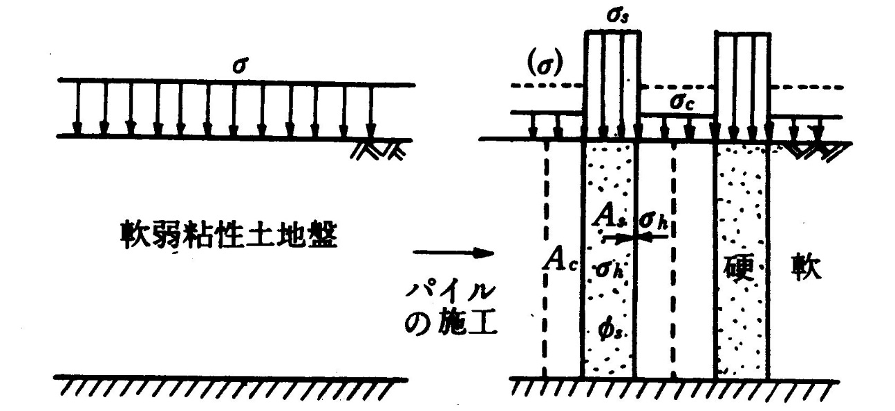
$$σ$$
$$σ_{c}$$
$$σ_{s}$$
$$A_{c}$$
$$σ_{h}$$
$$A_{s}$$
Soft clay
$$σ$$
Soft clayey ground

Hard
- Original ground (b) After improvement

Fig.4.14 Mechanism of bearing capacity on composite ground
(Suematsu, 1991)
（中澤先生からOriginalを貰う）

$$α$$
o
R

$$σ_{Z}$$
Z

Z

$$τ_{c}$$
$$τ_{s}$$

Fig.4.15 Shear strength of composite ground (Suematsu, 1991)

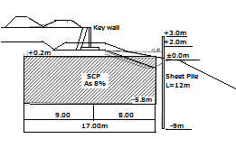
(a) Section
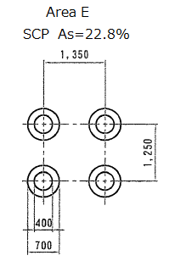

(b) Plane
Borehole3
Borehole1
Borehole2

(c) N-Value

Fig.4.16 Case history of SCP (Provision by JAFEC, 2016)
(原田さんにお尋ね)

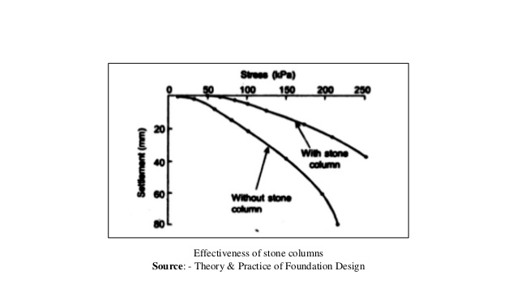
トレースしてください。
Fig.4.17 Effectiveness of stone columns for settlement (Engelhardt- et el. 1974)
(Engelhardt- et el .のOriginalからスキャンする)

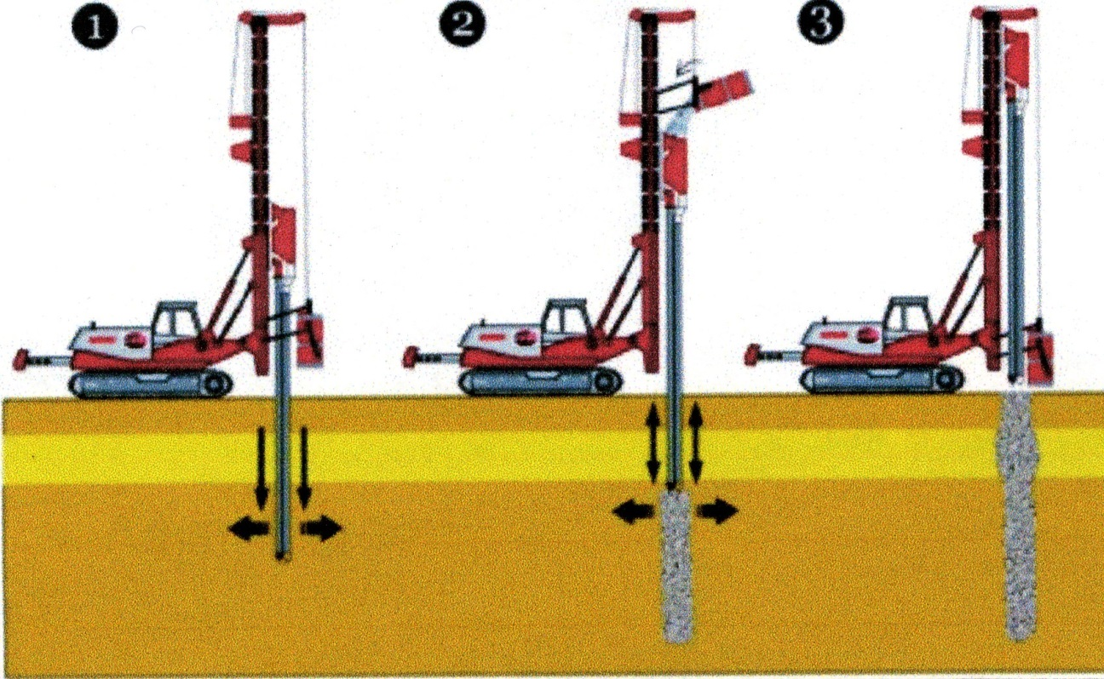
Positioning & drilling
Stone placing & compaction
Completed
Fig.4.18 Procedure of Stone Column Method (CivilDigital, 2017)不要
（書き直す：学生へ）

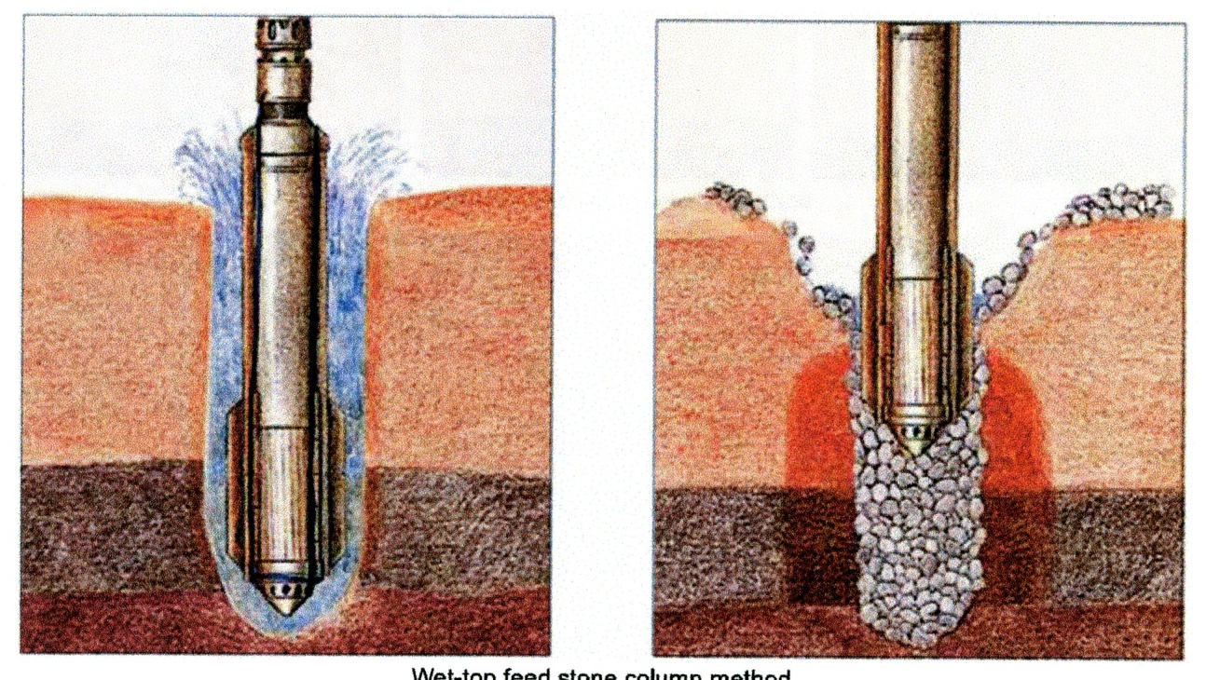
- Driving and jetting
- Compacting of stone

Fig.4.19 Wet-top Feed System (Zetas)
（書き直す：学生へ）

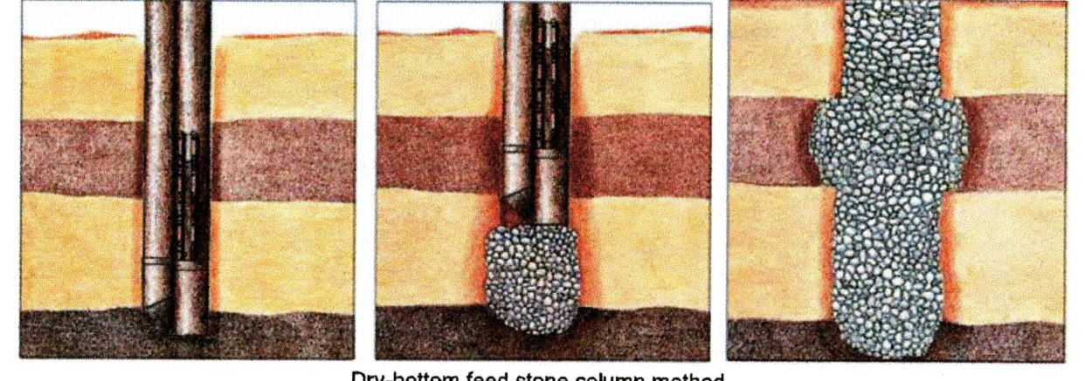
a) Driving
c) Completed stone column
b) Compacting

Fig.4.20 Dry-bottom Feed System (Zetas)
（書き直す：学生へ）

2-3D
D

- Long stone column with firm or floating support-bulging failure
b) Short column with rigid base-
shear failure

Fig4.21 Failure of Stone Column (Barksdale & Bachus, 1983)

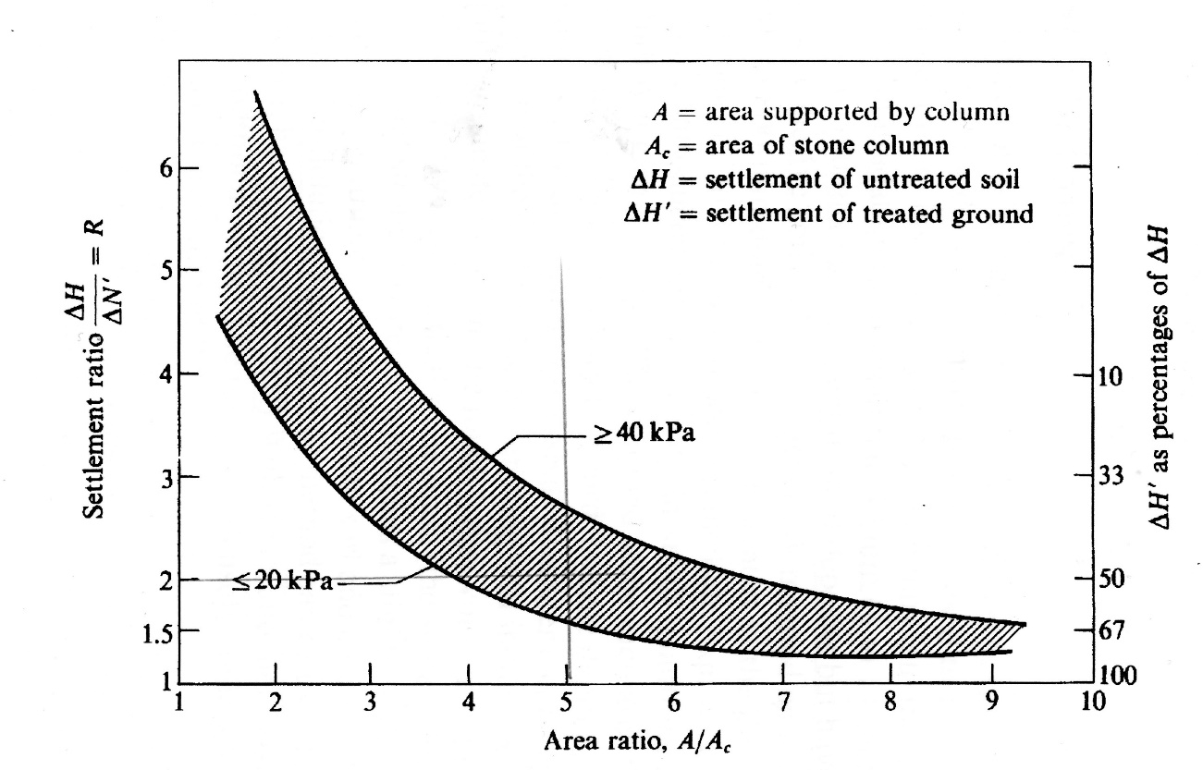
ΔH’?
Fig.4.22 Settlement reduction with stone columns (Greenwood and Thomson, 1984)
（Originalを探す）

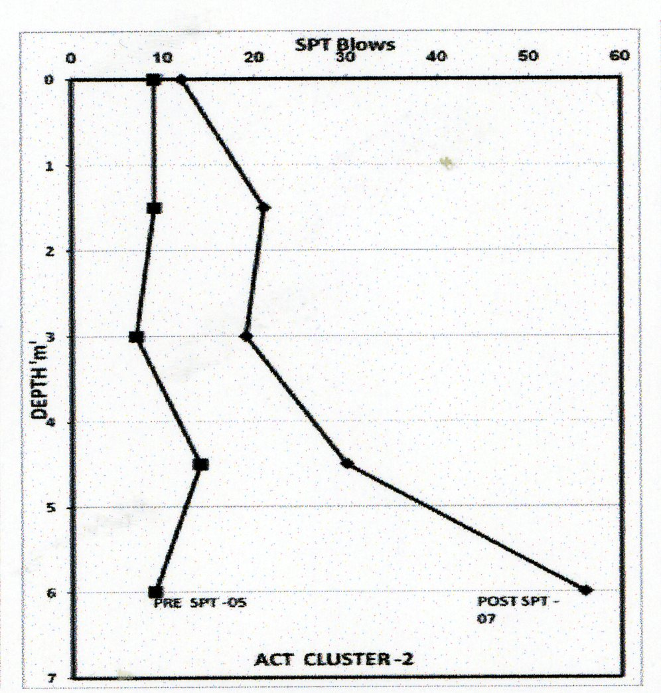
トレースを依頼中のものと差し替える。
5月27日のメール参照
Fig.4.23 Results of ground improvement by SPT N Values
(Modified by authors, original data from Basarkar et al, 2009)

(作り直す学生へお願い)

